BLUETOOTH BASED HOME AUTOMATION USING ARDUINO

CONTENTS

* Summary of Proposed project
* Background
* Objectives of project work
* Methodology
* Description of project work
* Expected outcomes
* References

**1. Summary of Proposed work**

Bluetooth-based home automation system using cell phones: In a Bluetooth-based home automation system the home appliances are connected to the Arduino BT board at input-output ports using the relay module. The program of Arduino BT board is based on high-level interactive C language of microcontrollers; the connection is made via Bluetooth module. The password protection is provided so only authorized user is allowed to access the appliances. The Bluetooth connection is established between the Arduino BT board and the phone for wireless communication. In this system, the python script is used and it can install on any of the Symbian OS environments, it is portable. One circuit is designed and implemented for receiving feedback from the phone, which indicates the status of the device.

**2. Background of the project**

We tend to be very ignorant and absent-minded when it comes to turning OFF the lights or any electrical appliances. But, this can be used in automated rooms where lights and fans can be turned ON and OFF based on the control given from mobile. The Bluetooth connection is established between the Arduino BT board and the phone for wireless communication. In this system, the python script is used and it can install on any of the Symbian OS environments, it is portable.

**3. Objectives of the project work**

a. Arduino is controlled using a mobile application.

b. When it is ON or OFF in the app.

c. Relay turns ON or OFF based on input.

d. Turns Lights ON or OFF based on particular switch control.

**4. Methodology**

This project is based on automatic switching ON and OFF the lights, fan, and electrical appliances inside the room based on controls.

**5. Description:**

**5.1 List of components**

a. Arduino Uno

b. Relay module 4 channel

c. Bluetooth module H C-05

d. Light socket

e. Jumper wires

f. Battery

g. Mobile application

**5.2 Circuit diagram**

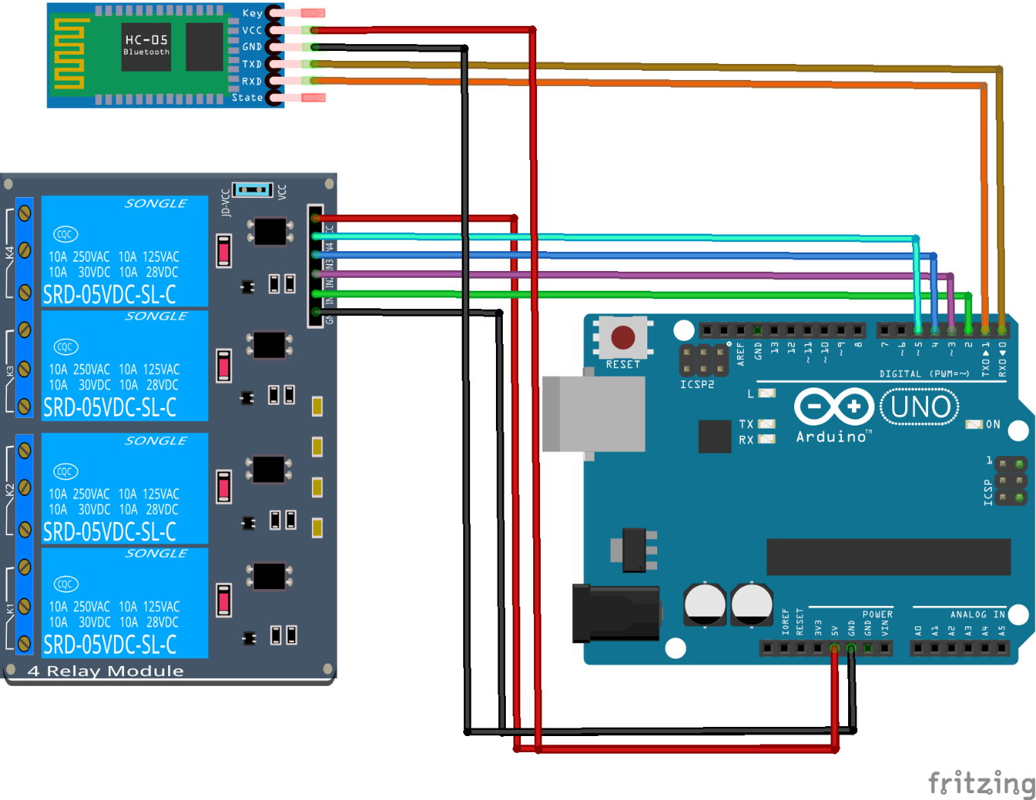

**5.3 Working**

**1. Arduino UNO:** The Arduino Uno is a microcontroller board based on the ATmega328P. It has 14 digital input/output pins (of which 6 can be used as PWM outputs), 6 analog inputs, a 16MHz quartz crystal, a USB connection, a power jack, an ICSP header, and a reset button. Simply connect it to a computer with a USB cable or power it with an AC-to-DC adapter or battery to get started.

**2. Bluetooth module HC-05:** The HC-05 module is an easy to use Bluetooth SPP (Serial Port Protocol) module that can be used in a Master or Slave configuration, making it a great solution for wireless communication. This serial port Bluetooth module is a fully qualified Bluetooth V2.0+EDR (Enhanced Data Rate) 3Mbps Modulation with a complete 2.4GHz radio transceiver and baseband. It uses the CSR Bluecore 04-External single-chip Bluetooth system with CMOS technology and with AFH (Adaptive Frequency Hopping Feature).

**3. Relay module:** A relay allows you to turn on or turn off a circuit using voltage and/or current much higher than what Arduino could handle. Relay provides complete isolation between the low voltage circuit on the Arduino side and the high voltage side controlling the load. It gets activated using 5V from Arduino, which, in turn, controls electrical appliances like fans, lights, and air-conditioners, etc.

**4. Battery:** it is used to supply power for both Arduino and relay modules.

**5.4 working procedure:**

Open Arduino IDE and compile the program (sketch). Upload the sketch to the Arduino board. Switch on the power supply to Arduino by connecting it to a 12V power source. Pair the Bluetooth module with your Android phone type password ‘1234’ (default password) of the Bluetooth module. Click Bluetooth Image on the app to connect it with the Bluetooth module. It automatically connects and displays as Connected in the app. You are now ready to control the appliances using the app. You can use on/off buttons to control the appliances. You can control 8 electrical appliances by using an 8- 8-channel relay.

**6. Expected outcomes:**

a. Arduino is controlled using a mobile application.

b. When it is ON or OFF in the app.

c. Relay turns ON or OFF.

d. Lights should turn ON or OFF based on particular switch control.

**8. Reference:**

<https://www.instructables.com>

<https://www.electronicshub.com>